Pengajuan Dana 19 September 2024

1. Biaya BBN Voxy Hitam B 2121 KN

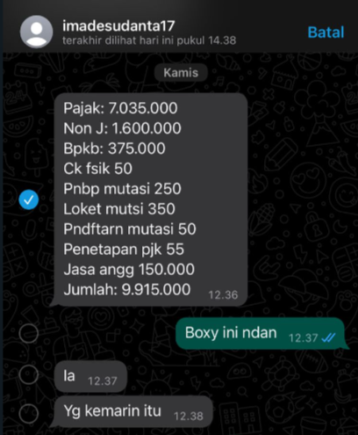

1. Biaya Pasang Bumper Jeep Short 2015 Hitam B 1780 BJT

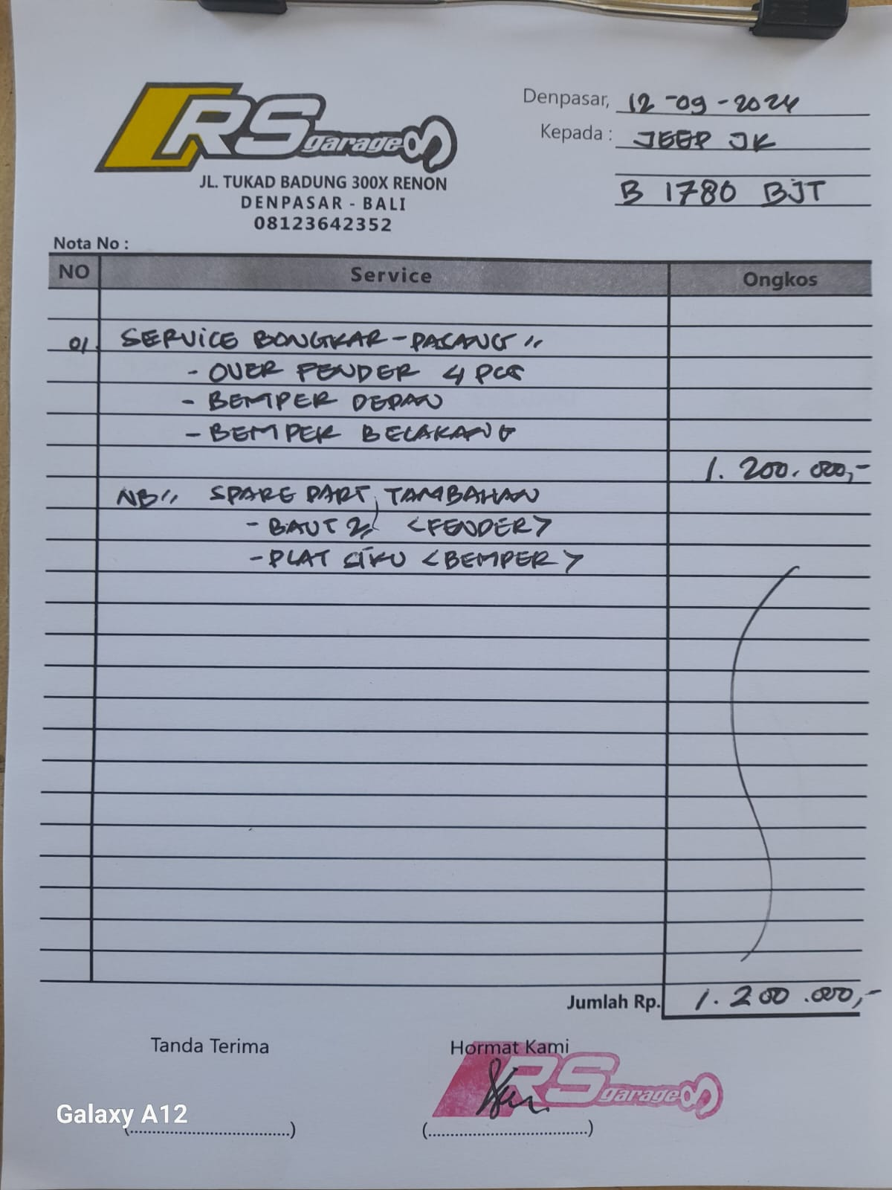

1. Samsat Mini Electric B 1242 JNO

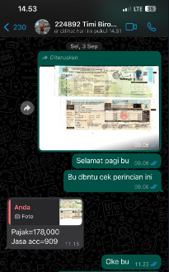

1. Samsat Lexus NX Hitam DK 1166 AF

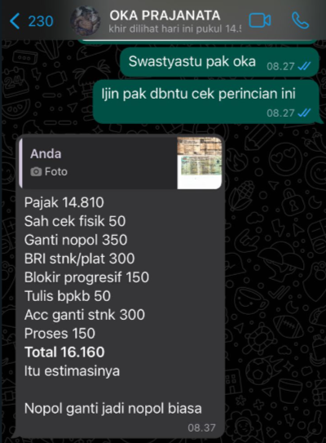

1. Ganti Sensor ABS Jeep Pak Mangku B 568 ALD

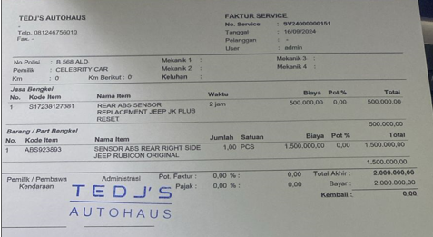

1. Biaya Cat Raize dan Rush Hitam

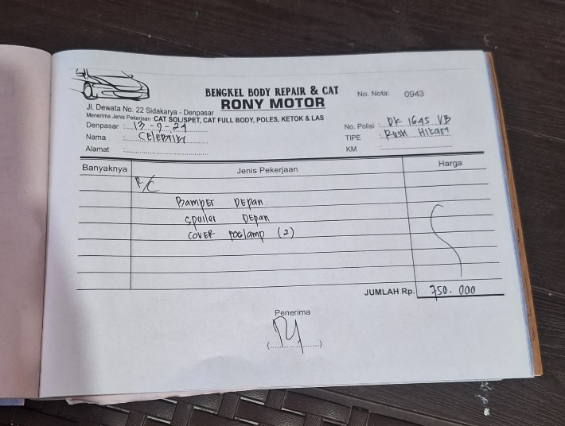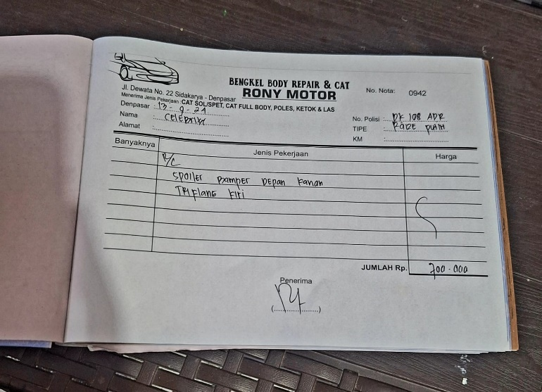

1. 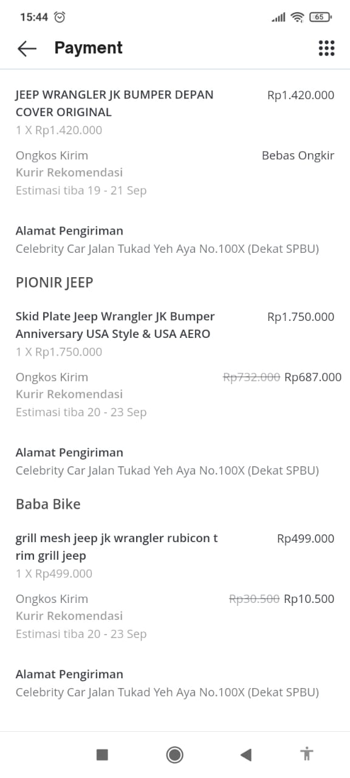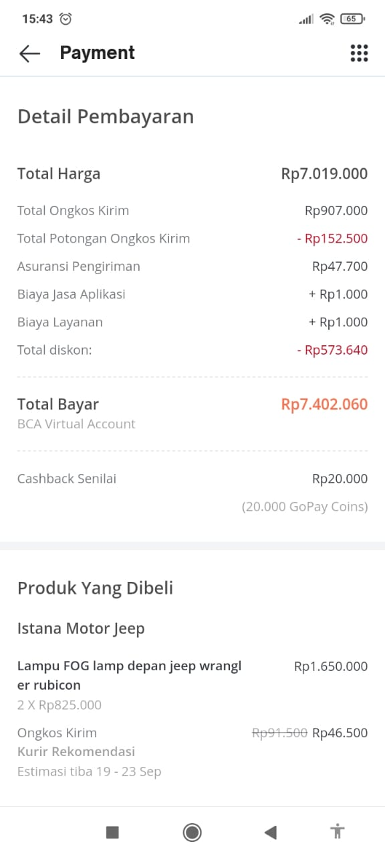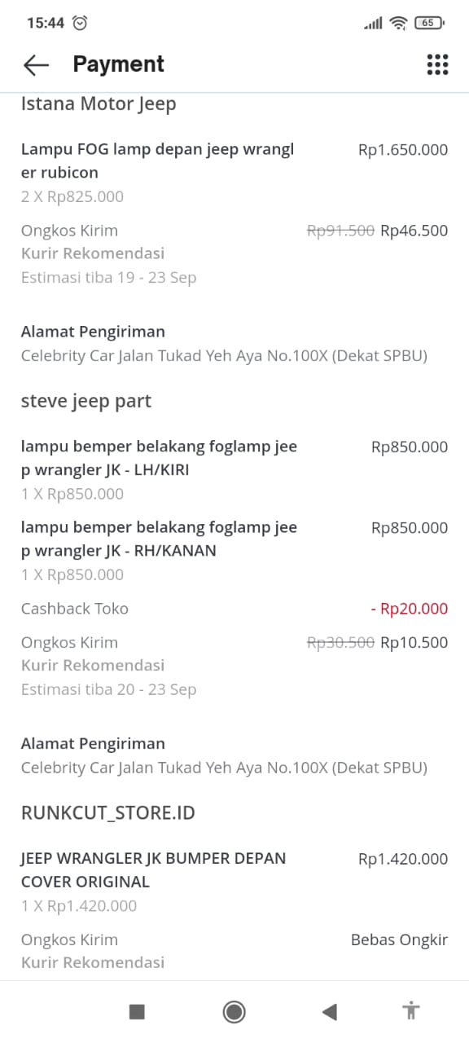Beli Part Jeep Short 2015
2. Biaya Jeep Short 2015

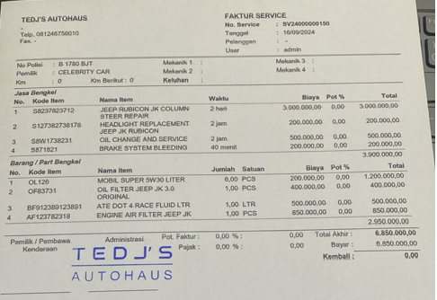

1. BUAT DUPLIKAT KUNCI HONDA ACCORD

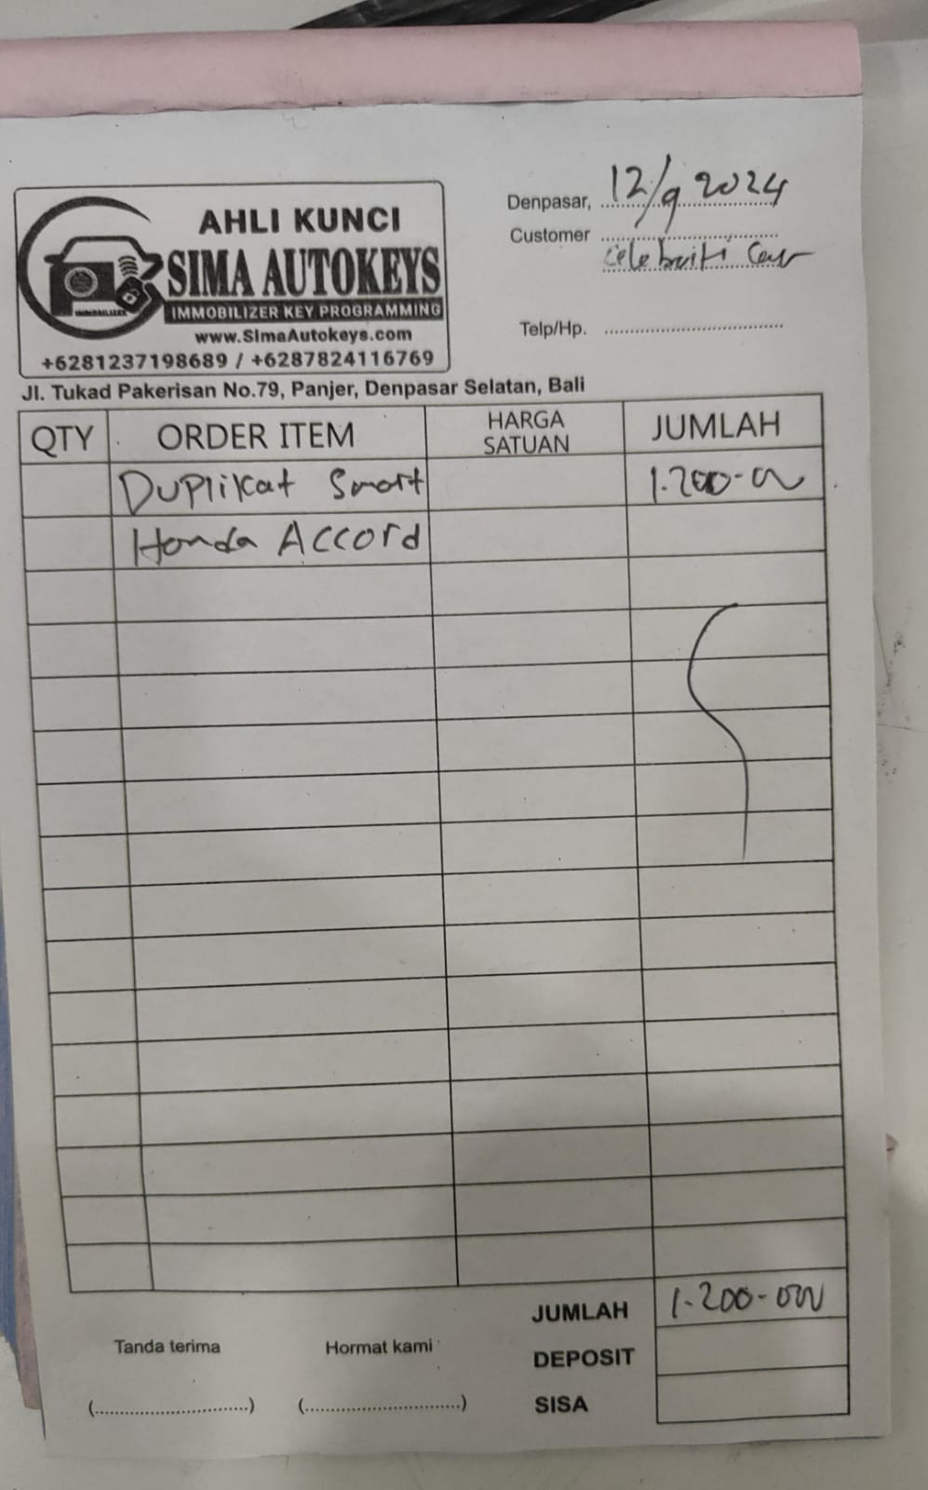

1. 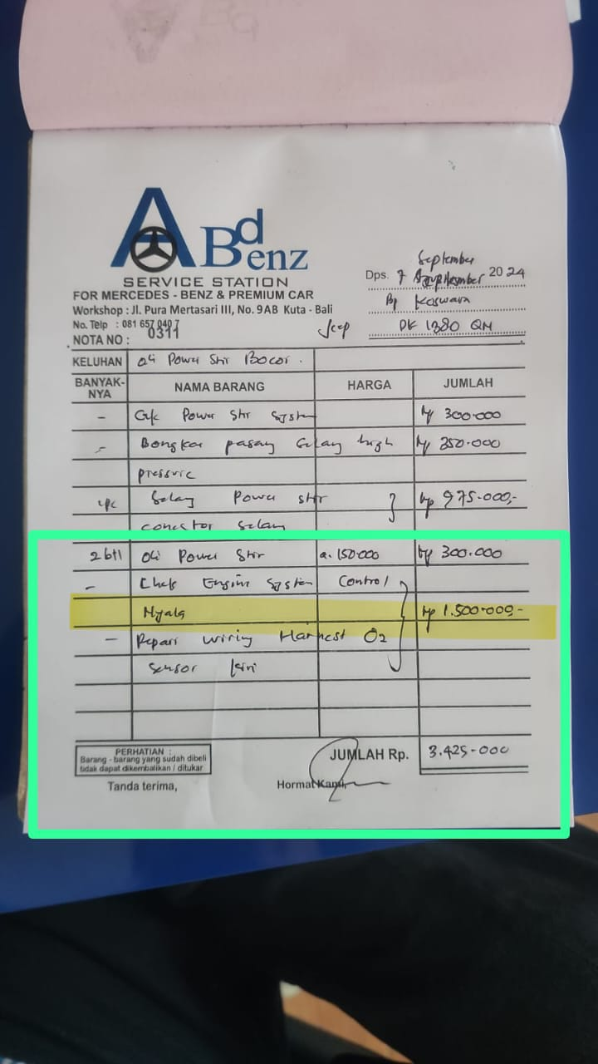SERVICE MOBIL BU OCHA DK 1380 QN
2. 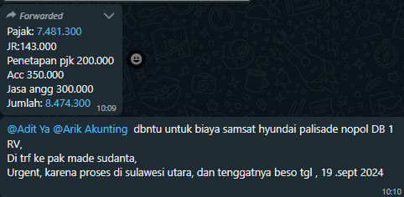SAMSAT PALISADE DB 1 RV